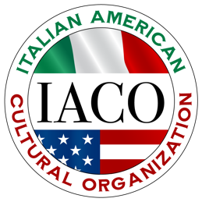

ITALIAN AMERICAN CULTURAL ORGANIZATION

Spirit of Italian Culture Scholarship Application—Deadline April 12, 2024

Name_________________________________________________________________________
Last First Middle

Address_______________________________________________________________________
Street City/Town State Zip Code

Phone__________________________________Email__________________________________

Name and Address of educational institution to which you are applying:

______________________________________________________________________________

______________________________________________________________________________

Education History:

High School you are attending_____________________________________________________

Awards, scholarships, or noteworthy achievements_____________________________________

______________________________________________________________________________

Activities, hobbies, and interests___________________________________________________

______________________________________________________________________________

Employment History:

Name of Employer Employment dates Type of work performed

______________________________________________________________________________

______________________________________________________________________________

______________________________________________________________________________

Applicant Signature_____________________________________Date_____________________

(Instructions on reverse side.)

Submit this application along with the following items:

1. An essay (approximately 150 words) on how your Italian-American heritage has helped shape your life and how you feel it will benefit you in achieving your goals. Type double-spaced, not to exceed two pages. (Special consideration is given to this essay.)

2. Three (3) letters of recommendation--at least one (1) from a teacher--no relatives, please.

3. Transcript.

(Please do not staple materials. Submitted documents will not be returned.)

Mail by April 12th to:

Italian American Cultural Organization
Scholarship Committee
c/o Joyce Annese
5 Rebecca Road
Whitman, MA 02382

